Citrix receiver or Citrix Workspace

How to associate the .ica file type:
Note: The common file path to the Citrix Receiver application below is C:\Program Files (x86)\Citrix\ICA Client\wfcrun32.exe

Download citrix Receiver

Automatically Open ICA Files
When clicking on an application or desktop to launch via Citrix Workspace or Citrix Storefront on an Internet Browser (not within Citrix Workspace App) and an ".ica" file shows in the download bar on the bottom left please follow these steps to automatically open said file:
ICA file is downloaded during the process. After the ICA file is downloaded, enable the browser to open similar files automatically.
Note: Instructions below are similar for other OS's when using Google Chrome, Firefox, or Edge Browsers.
Internet Explorer:
- Navigate to the Citrix Workspace Store or Citrix Storefront Store
- Select the resource you are trying to access - Application or Desktop
- You will receive a notification on the bottom of the browser to "Open, Save, Cancel"
- Select the Save.
- The download bar will now show to "Open, Open Folder, View Downloads",
- Select the drop-down list next to "Open" and select "Open With"
- Find and select "Connection Manager"
Google Chrome:
- Navigate to the Citrix Workspace Store or Citrix Storefront Store
- Select the resource you are trying to access - Application or Desktop
- Chrome will prompt a dialog box to save the '".ica" file
- Hit save to save it in the "Downloads folder"
- On the bottom left you will see the file, click the "^" which is the drop-down list for the file in the download bar and select "Always Open Files of This Type"
Firefox:
- Navigate to the Citrix Workspace Store or Citrix Storefront Store
- Select the resource you are trying to access - Application or Desktop
- Firefox will prompt you with a dialog box to save the '".ica" file
- Select "Do this automatically for files like this from now on"
- Select "Open With" and click "Browse"
- Select "Connection Manager"
Edge Browser:
- Navigate to the Citrix Workspace Store or Citrix Storefront Store
- Select the resource you are trying to access - Application or Desktop
- Edge automatically saves the file to the downloads folder by default
- On the bottom left you will see the file, click the "..." which is the drop-down list for the file in the download bar and select "Always Open Files of This Type"
Opera Browser:
- Navigate to the Citrix Workspace Store or Citrix Storefront Store
- Select the resource you are trying to access - Application or Desktop
- Opera automatically saves the file to the downloads folder by default
- On the top right you will see the downloads icon, click on the the "..." which is the drop-down list for the file in the download bar and select "Always Open Files of This Type"

Associate .ica File Type With Citrix Connection Manager
- On Windows computers, go to Control Panel > Settings > Apps > Default apps > Choose default apps by file type
- Under Name, find .ica file type.
- Ensure that the current default is set to Citrix Connection Manager. If not, click Change program and choose Citrix Connection Manager.
Note: Connection Manager is the wfcrun32 file located as C:\Program Files (x86)\Citrix\ICA Client\wfcrun32.exe

Remove or Disable Third Party Browser Adware
Remove or disable any third party browser based Adware software that could be interfering with the successful launch of the ICA file. Restart the browser after removing these software and try again.

Clear the "Do not save encrypted data to disk" Option
If you are using Internet Explorer, click Tools > Internet Options > Advanced tab and clear the option “Do not save encrypted data to disk.”. This option should be cleared because the dynamic files are stored in the Temporary Internet Files folder. When applications are clicked, a file is downloaded to the folder, then launched using MIME type. If access to the folder is disabled or not available, the process cannot occur successfully.
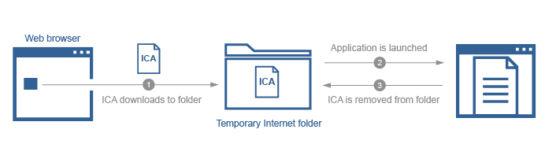

Below are for older Browser/Citrix Receiver Deployments:
No longer recommended to perform these steps in newer releases of Internet Browsers. Steps remain for any users not fully updated to the latest and greatest.

Add Website to Trusted Sites
Add the site to the Trusted sites list if using Internet Explorer browser using the following steps:
- Go to Tools > Internet Options > Security tab > Sites
- In the Add this website to the zone field, enter your organization's website and click Add.
- Repeat this for the .com, .net, .org, or .gov Web site addresses of your organization to allow the use of the ActiveX ICA client object for the launched connection to be automatically accepted.
Note: It might be required to also add any additional subdomain.domain.com URLs to the Trusted sites list in the Security tab setting if still experiencing unwanted prompts.
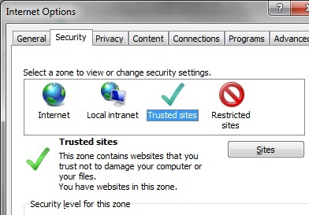

Disable ActiveX Filtering (Enable ActiveX)
Caution! Refer to the Disclaimer at the end of this article before using Registry Editor.
Configure Internet Explorer as follows to allow successful application launching:
- Disable ActiveX filtering feature for the Web Interface site, either by:
- Disabling ActiveX filtering globally:
Click Gear icon, select Safety, de-select ActiveX Filtering. Alternatively, press Alt key and click Tools menu (ActiveX filtering is enabled if a “tick” appears next to it and is disabled if the “tick” disappears).
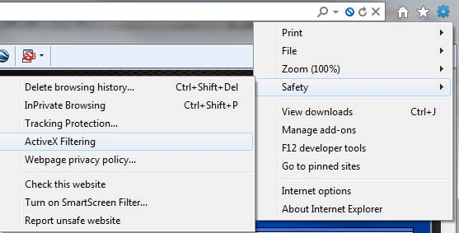
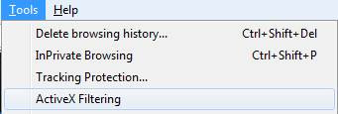
Or
- Disabling ActiveX filtering for an individual site when ActiveX filtering is enabled globally:
  - Log on to the Web Interface site and attempt to launch an application. At the end of the address bar a blue warning sign appears, indicating filtered content.
  - Click the blue warning sign and select Turn off ActiveX Filtering.
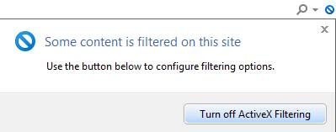
- Enable ICA launch using one of the following options:
- Add the site to the Trusted sites list: In the Security tab of Internet Options, add the Web Interface site to Trusted Sites list to allow the use of the ActiveX ICA client object for the launch.
Or
- Disable the MIME filter: Rename the following registry key: HKEY_CLASSES_ROOT\PROTOCOLS\Filter\application/x-ica
- Log off and close window then restart the browser after making this change.

Enable Citrix ICA Client plugin
Configure Internet Explorer as follows to allow successful application launching:
- Enable Citrix ICA Client IE plugin by following the steps below:
  - Launch Internet Explorer
  - Go to Tools > Manage add-ons
  - Select Citrix ICA Client plugin and click Enable
- 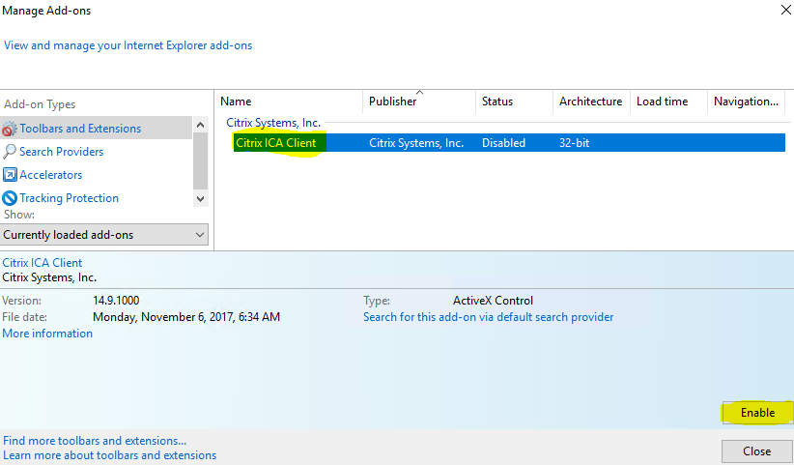

Problem Cause
There can be a number of reasons for the issue including but not limited to:
- The *.ica file on the client needs to be associated with Citrix Workspace App
- Outdated Internet Browsers in use

Additional Resources
- CTX139939 - Microsoft Internet Explorer 11 - Citrix Known Issues
- CTX200889 - Receiver for Web Workaround with NPAPI Support Removal in Google Chrome
- CTX126653 – Citrix Online Plug-in for Windows with Internet Explorer 9 Support
- The ICA Mime type has not been properly configured on the Web server software or browser
- Citrix Discussions - IE 11 (Website cannot find required software)
- CTX238286 - Citrix Workspace App Launcher is unable to launch applications automatically with Apple Safari 12

Disclaimer
Caution! Using Registry Editor incorrectly can cause serious problems that might require you to reinstall your operating system. Citrix cannot guarantee that problems resulting from the incorrect use of Registry Editor can be solved. Use Registry Editor at your own risk. Be sure to back up the registry before you edit it.
Was this page helpful?Please provide article feedback.

